ASSIGNMENT – 12
- Install Wireshark on your laptop, start a capture on your main network interface, and visit any website (like instagram.com). Stop the capture and note down the protocol names you see in the packet list.

Step 1: Install Wireshark
- Visit the official website: Download Wireshark.
- Download the Windows installer.
- Run the installer and follow the installation instructions.
- Install Npcap when prompted, as it enables packet capture.
Step 2: Start a packet capture
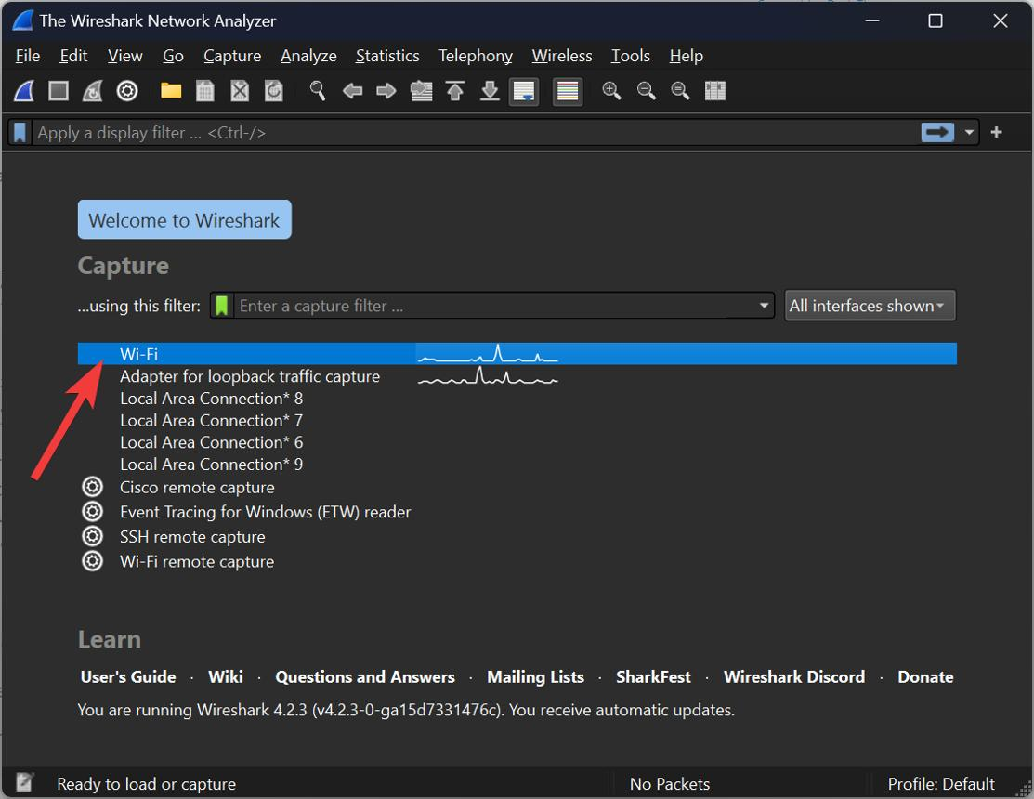
1. Open Wireshark
Select your active network interface, such as Wi-Fi or Ethernet. Choose the interface showing network activity.
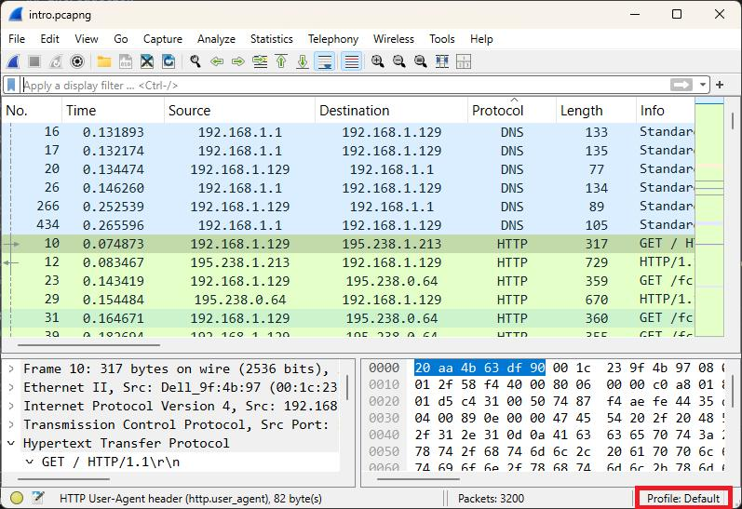
2. Start capturing
Double-click the interface and wait for packets to appear in the packet list.
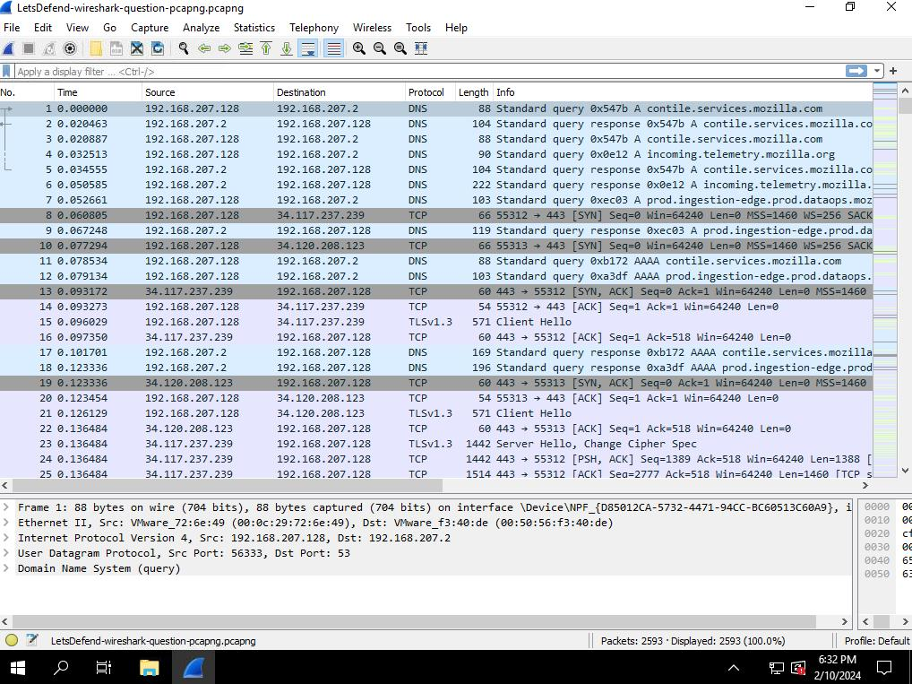
3. Visit a website
Open your browser and visit https://www.instagram.com/. Browse for 15–30 seconds.
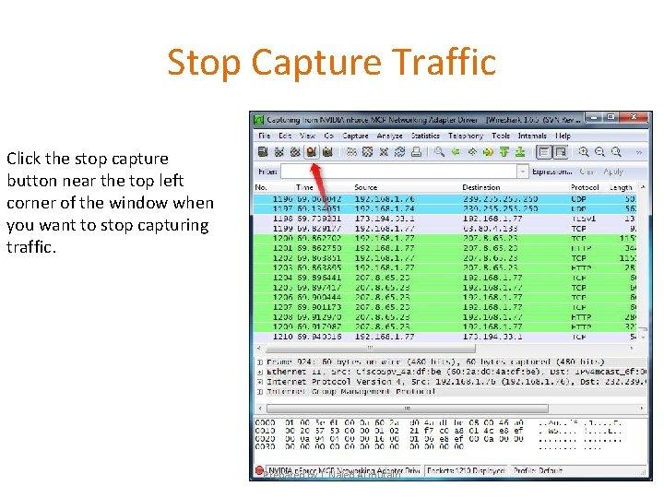
4. Stop the capture
Return to Wireshark and click the red Stop button.
Step 3: Note the protocol names
Look at the Protocol column in Wireshark's packet list. Depending on your network, browser, and website, you may see protocols such as these:
Protocol | Purpose
DNS | Resolves a website's domain name to an IP address.
TCP | Provides reliable transport of data.
TLS | Secures encrypted communication.
QUIC | Supports modern encrypted web connections, commonly used with HTTP/3.
HTTP2 | Transfers web content using HTTP/2.
UDP | Transports datagrams and is used by protocols such as QUIC.
ARP | Resolves IPv4 addresses to local network hardware addresses.
These are examples, not confirmed results from your capture. The exact protocols depend on your network traffic.
Step 4: Write your observation
You can use this format in your assignment after checking your actual capture:
Observation: I installed Wireshark and captured network traffic while visiting Instagram.
Result: Wireshark helped me observe the protocols used during network communication.

- Pick any 3 packets from your Wireshark capture and identify which OSI layer each packet mainly represents (for example, HTTP for Application layer, TCP for Transport layer, etc.).<br><br><em><strong>Hint:</strong> Use the Protocol column and Info details in Wireshark to help you map protocols to OSI layers.</em>

Wireshark Assignment: Mapping Packets to OSI Layers
The following table shows three example packets you may observe in Wireshark while visiting a website. Check your own capture and use the matching packets for your assignment.
No. | Protocol (Wireshark) | Example Info Details | OSI Layer | Reason
1 | DNS | Standard query for www.instagram.com | Layer 7 – Application | DNS translates domain names into IP addresses.
2 | TCP | 443 → 52134 [ACK] | Layer 4 – Transport | TCP provides reliable data delivery between applications.
3 | Ethernet II | Source and destination MAC addresses | Layer 2 – Data Link | Ethernet frames transfer data between devices on a local network.
How to identify these packets in Wireshark
- Open your captured packet list.
- Check the Protocol and Info columns.
- Select a packet and expand its details in the middle pane.
- Match the protocol to its main OSI layer using the table above.

- Create a colorful diagram of the OSI Model using any drawing tool (MS Paint, Canva, or even paper and upload a photo). For each layer, add a real-world example from apps you use daily (e.g., WhatsApp uses the Application layer, Instagram images use the Presentation layer, etc.).

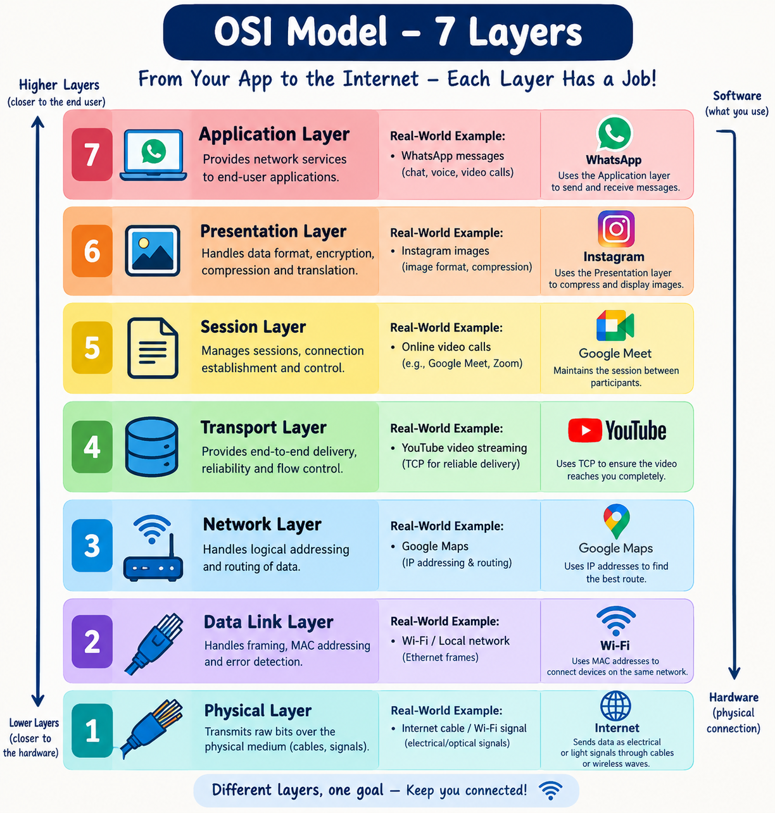

- Explain how sending a message on WhatsApp travels through at least 4 layers of the OSI Model, describing what happens at each layer in your own words.<br><br><em><strong>Hint:</strong> Think about how your message is typed, packaged, sent over the internet, and received.</em>

How a WhatsApp Message Travels Through the OSI Model
When I send a message like “Hello!” on WhatsApp, it passes through different OSI layers before reaching my friend's phone.
OSI Layer | Layer Name | What Happens When Sending a WhatsApp Message
Layer 7 | Application | I type “Hello!” in WhatsApp and press the Send button.
Layer 6 | Presentation | The message data is represented in a suitable format and protected using encryption so unauthorized people cannot easily read it.
Layer 4 | Transport | The data is transported between devices using appropriate transport protocols, helping deliver it to the destination.
Layer 3 | Network | The message packets are routed across networks using IP addresses to reach the recipient's device.
Layer 2 | Data Link | The data is placed into frames and sent across the local network, such as my Wi-Fi connection.
Layer 1 | Physical | The data travels as radio signals over Wi-Fi or as electrical or optical signals through network infrastructure.

